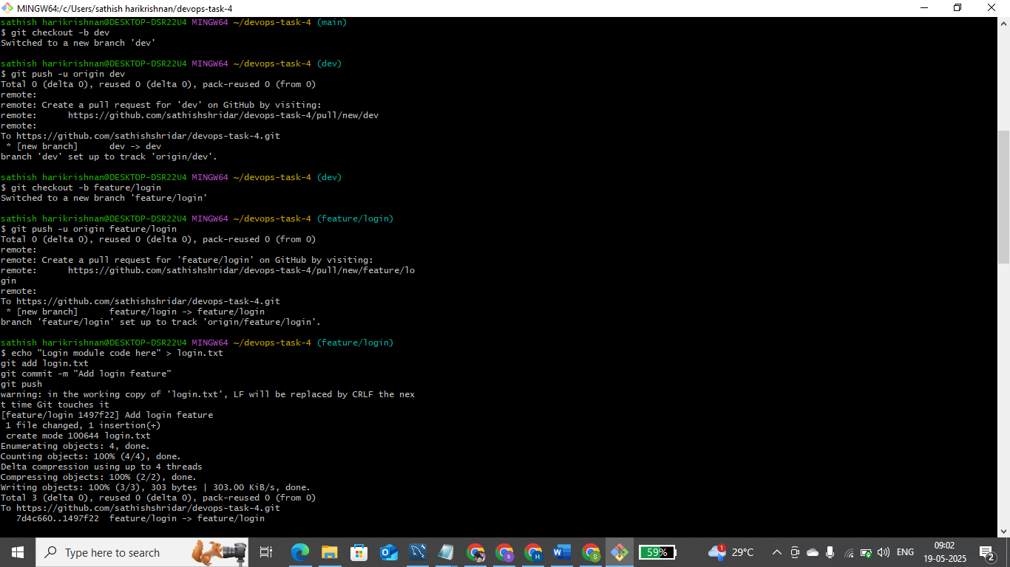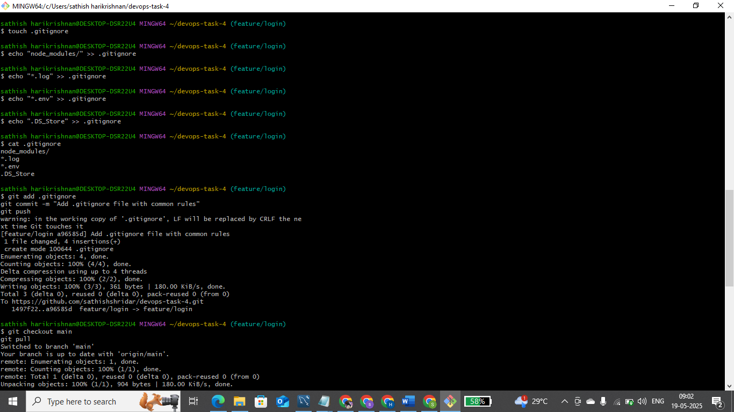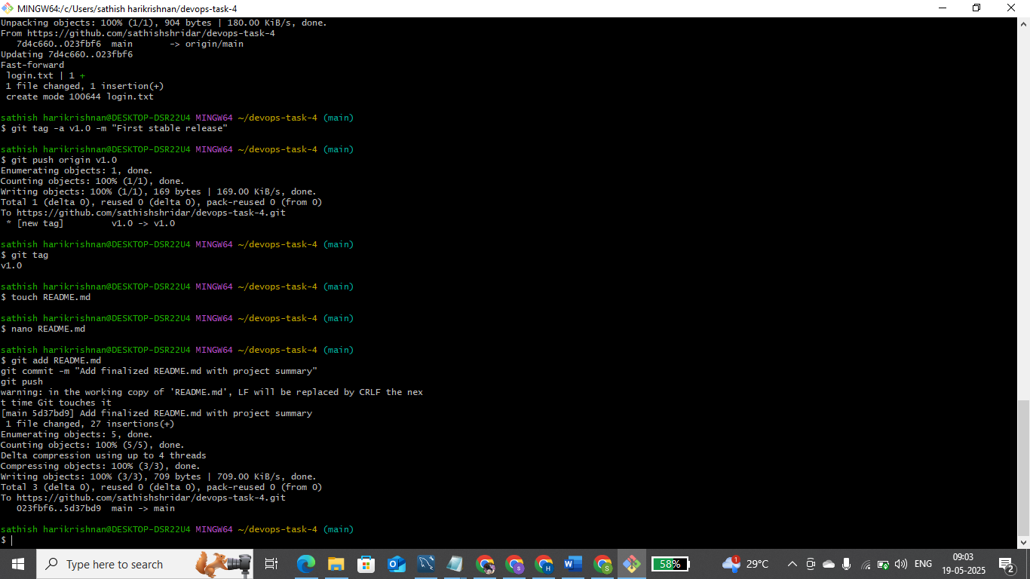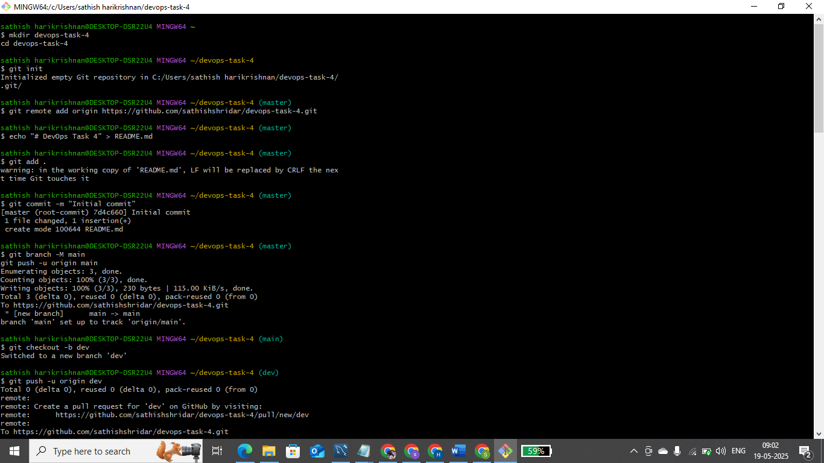

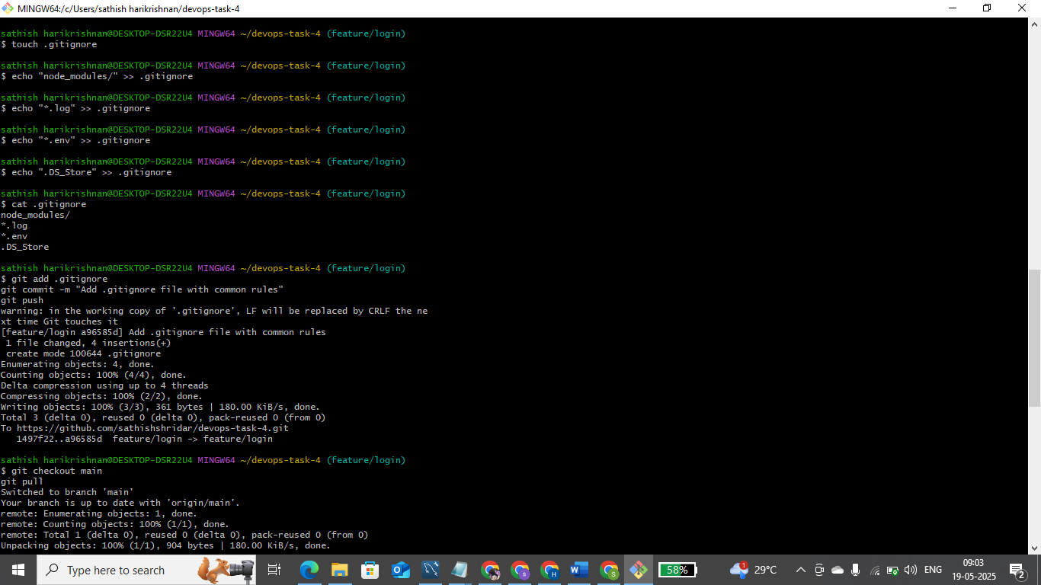

**✅ DevOps Task 4 — Project Summary**

**📌 Project Title:**

**Version-Controlled DevOps Project with Git**

**🎯 Objective:**

To understand and apply **Git best practices** by managing a DevOps project using **version control**, **branching**, **pull requests**, and **documentation** on GitHub.

**🛠️ Tools Used:**

* **Git** – for version control
* **GitHub** – for remote repository hosting and collaboration
* **Git Bash** – as the command-line tool

**🌿 Git Workflow & Structure:**

* Initialized a local Git repository
* Linked it to a remote GitHub repository
* Created and pushed the following branches:
  + main: Stable release
  + dev: Development branch
  + feature/login: Feature-specific work
* Used **Pull Requests** to:
  + Merge feature/login into dev
  + Merge dev into main

**📁 Key Features:**

* .gitignore file created to exclude sensitive/unwanted files (e.g., *.log, .env, node_modules/)
* Tag v1.0 added to mark the first stable release
* Documented all steps and process using README.md

**📝 Deliverables:**

* A GitHub repository with:
  + Clean commit history
  + Logical branch structure
  + Pull request workflow
  + Version tagging
  + Markdown documentation

**🚀 Learning Outcome:**

* Gained hands-on experience with **Git commands**, **branching strategies**, **conflict-free merging**, **tagging**, and writing effective **documentation**
* Understood the real-world DevOps workflow for team collaboration and project versioning